14 Cisco Router and Switch Basics

- Lab Exercise

In this lab you will complete a basic configuration on a switch, verify Cisco Discovery Protocol CDP and analyse the effects of interface speed and duplex configuration.

Lab Topology

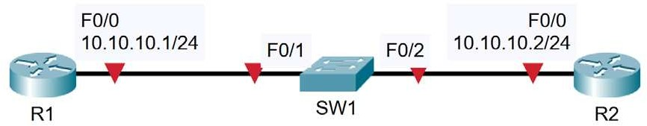

Load the Startup Configurations

Open the ’14 Cisco Router and Switch Basics.pkt’ file in Packet Tracer to load the lab.

Cisco Router and Switch Initial Configuration

- Configure Router 1 with the hostname ‘R1’

- Configure Router 2 with the hostname ‘R2’

- Configure Switch 1 with the hostname ‘SW1’

- Configure the IP address on R1 according to the topology diagram

- Configure the IP address on R2 according to the topology diagram

- Give SW1 the management IP address 10.10.10.10/24

- The switch should have connectivity to other IP subnets via R2

- Verify the switch can ping its default gateway

- Enter suitable descriptions on the interfaces connecting the devices

- On SW1, verify that speed and duplex are automatically negotiated to 100 Mbps full duplex on the link to R1

- Manually configure full duplex and FastEthernet speed on the link to R2

- What version of IOS is the switch running?

CDP Configuration

- Verify the directly attached Cisco neighbors using Cisco Discovery Protocol

- Prevent R1 from discovering information about Switch 1 via CDP

- Flush the CDP cache on R1 by entering the ‘no cdp run’ then ‘cdp run’ commands in global configuration mode

- Verify that R1 cannot see SW1 via CDP

Switch Troubleshooting

- Verify the status of the switch port connected to R2 with the show ip interface brief command. It should show status and protocol up/up.

- Shut down the interface connected to R2 and issue a show ip interface brief command again. The status and protocol should show administratively down/down.

- Bring the interface up again. Verify the speed and duplex setting.

- Set the duplex to half on Switch 1. Leave the settings as they are on R2.

- Verify the state of the interface.

- Set the duplex back to full duplex.

- Set the speed to 10 Mbps.

- Check if the interface is still operational.

- Check if the interface is operational on R2. What is the status of the interface?

